PAGE - 4 LONG WALK TO FREEDOM

That day had come about through the unimaginable sacrifices of thousands of my people, people whose suffering and courage can never be counted or repaid. I felt that day, as I have on so many other days, that I was simply the sum of all those African patriots who had gone before me. That long and noble line ended and now began again with me. I was pained that I was not able to thank them and that they were not able to see what their sacrifices had wrought.
Unimaginable- difficult or impossible to imagine
Patriots- a person who vigorously supports their country and is prepared to defend it against enemies
This equal and free country was a result of sacrifices of countless other men and women who have fought all their lives for this day. The author wishes if he could thank them all but unfortunately, they didn’t live to see the result of their courage. Nelson Mandela gathered his courage and power from all these people and thus, wishes to make them proud.

The policy of apartheid created a deep and lasting wound in my country and my people. All of us will spend many years, if not generations, recovering from that profound hurt. But the decades of oppression and brutality had another, unintended, effect, and that was that it produced the Oliver Tambos, the Walter Sisulus, the Chief Luthulis, the Yusuf Dadoos, the Bram Fischers, the Robert Sobukwes of our time* — men of such extraordinary courage, wisdom and generosity that their like may never be known again. Perhaps it requires such depths of oppression to create such heights of character. My country is rich in the minerals and gems that lie beneath its soil, but I have always known that its greatest wealth is its people, finer and truer than the purest diamonds.
Apartheid- a policy or system of segregation on grounds of race
Profound- very great or intense
Unintended- not planned or meant

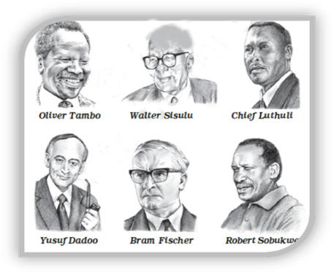
The oppression policy scarred many people and it will take a long time for them to move on. The author mentions that this hard time had its negative impacts but it also exposed a lot of strong and courageous men who stood up and raised their voice. Thus, it required that level of unjust treatment to produce such great heroes. South Africa, he says, is rich in minerals and gems but its greatest strength lies in its people.

It is from these comrades in the struggle that I learned the meaning of courage. Time and again, I have seen men and women risk and give their lives for an idea. I have seen men stand up to attacks and torture without breaking, showing a strength and resilience that defies the imagination. I learned that courage was not the absence of fear, but the triumph over it. The brave man is not he who does not feel afraid, but he who conquers that fear.
Comrades- a colleague or a fellow member of an organisation
Resilience- the ability to deal with any kind of hardship and recover from its effects
Defies- refuse to obey
Triumph- great victory or achievement
Nelson Mandela gained his strength to stand against the wrong from all the great nationalists he mentioned above, who have even risked their lives for freedom and tolerated ill treatment, but never stopped fighting. He learned that “courage” didn’t mean the absence of fear, but the ability to overcome fear. The man who overcomes his fear is called brave.

